 | 12.1.21 Editors - Geometry Nodes Editor - Header - Add Menu - Curve - Topology
Table of content
Detailed table of content 1
Add menu - Curve Topology 2
Offset Points in Curve 2
Curve of Point 2
Points of Curve 3

Detailed table of content
Detailed table of content
Detailed table of content 1
Add menu - Curve Topology 2
Offset Points in Curve 2
Inputs 2
Point Index 2
Offset 2
Outputs 2
Is Valid Offset 2
Point Index 2
Curve of Point 2
Inputs 2
Point Index 2
Offset 2
Outputs 3
Curve Index 3
Index in Curve 3
Points of Curve 3
Inputs 3
Curve Index 3
Weights 3
Sort Index 3
Outputs 3
Point Index 3
Total 3

Add menu - Curve Topology
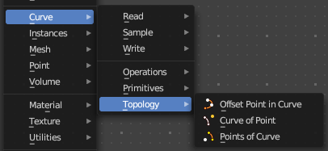
Curve topology related nodes.

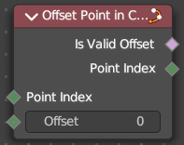
Offset Points in Curve
Offset a control point index in the curve.

Inputs

Point Index
The point index of the curve.

Offset
Offset of the point index.

Outputs

Is Valid Offset
Outputs true if the evaluated controlpoint plus the offset is a valid index.

Point Index
The index of the control point plus the offset.

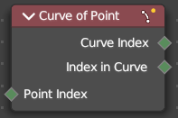
Curve of Point
Retrieve the curve of which the control point is part of.

Inputs

Point Index
The point index of the curve.

Offset
Offset of the point index.

Outputs

Curve Index
The curve of which the control point is part of.

Index in Curve
How far along the curve the control point is.

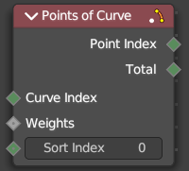
Points of Curve
Retreive a point index within a curve.

Inputs

Curve Index
The curve to retreive the data from

Weights
Values to sort the curve points.

Sort Index
The point to output.

Outputs

Point Index
The output point.

Total
The number of points in the curve.

